**Questions (Part 1)**

1. Sketch three pole-zero plots for a = 0.8, 0.5, and 0.8. This can be done using the MATLAB command zplane(). The inputs are the same as in the freqz() command. Determine if each is high-pass or low-pass.
   1. See Figures 3 – 5. Highpass, highpass, lowpass for a = 0.8, 0.5, -0.8
2. Comment on the effect of pre-emphasis on the sound and in the spectrogram of the female sentence.
   1. See caption of Figure 1
      1. “Spectrogram of a filtered and unfiltered female voice. Evidently, the filtered voice contains higher power at higher frequencies according to the graph, and can especially be seen from time t = 1 to time t = 1.4”
      2. Effect on the Sound: The sound sounds more tin-like
3. Describe the effect of pre-emphasis on the spectrum of the steady-state
   1. See Caption of Figure 2
      1. At Steady-State, this is how both the unfiltered and filtered voices can be seen in the frequency domain. Evidently, filtering adds more power to higher frequency spectral components while attenuating lower frequency components.

**Questions (Part 2)**

1. Determine the approximate spectral locations for the first three formant frequencies.
   1. See caption for of Figure 6:
      1. “Formant Frequencies for a Male saying “/a/”. The first three formants can be observed to occur around 750 Hz, 1250 Hz, and 2400 Hz.”

**Questions (Part 3)**

1. Determine the pitch period for the “\female a" sound in samples. Determine the pitch period in seconds. (Note that the sampling rate is Fs = 8kHz.) Determine the fundamental frequency of the speaker.
   1. See the caption for figure 7.
2. Repeat the previous question for the “\male a" sound.
   1. See the caption for figure 7.
3. Now use the file rex.m to record your own voice. Running the file will prompt you to speak into your computer's microphone. If your computer does not have a microphone, you may record yourself using a smartphone, save the file to your computer, and import the audio data from the audio file as directed in the script. Say the syllable /a into the microphone for 2 seconds. The script will produce the wave form, spectrum, and spectrogram of the utterance. Use any of them to estimate your own pitch. For the waveform, you can find a segment that shows strong periodicity and estimate the period. For the spectrum, you can zoom in to estimate the distance between adjacent pitch peaks. For the spectrogram, you can estimate the distance between harmonics. You may choose your favorite method.
   1. See caption for figure 8, pitch estimated at 118.69 Hz.

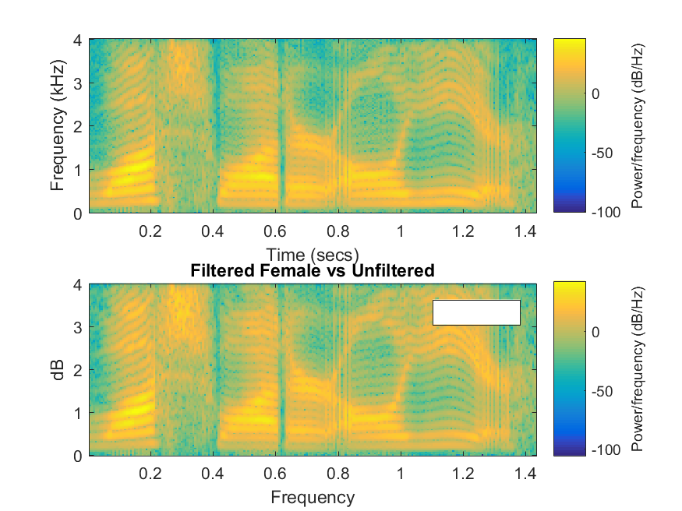

Figure 1: Spectrogram of a filtered and unfiltered female voice doing a /a/ sound. Evidently, the filtered voice contains higher power at higher frequencies according to the graph, and can especially be seen from time t = 1 to time t = 1.4

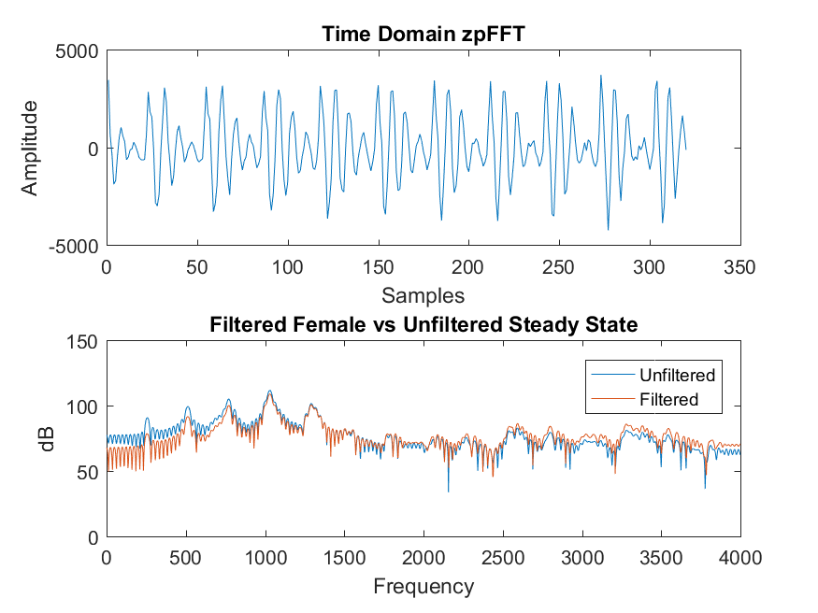

Figure 2: At Steady-State, this is how both the unfiltered and filtered voices can be seen in the frequency domain. Evidently, filtering adds more power to higher frequency spectral components while attenuating lower frequency components.

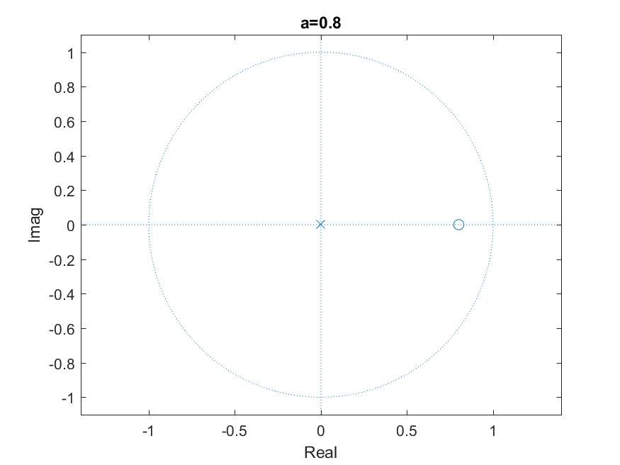

Figure 3: High-Pass Filter



Figure 4: High-Pass Filter

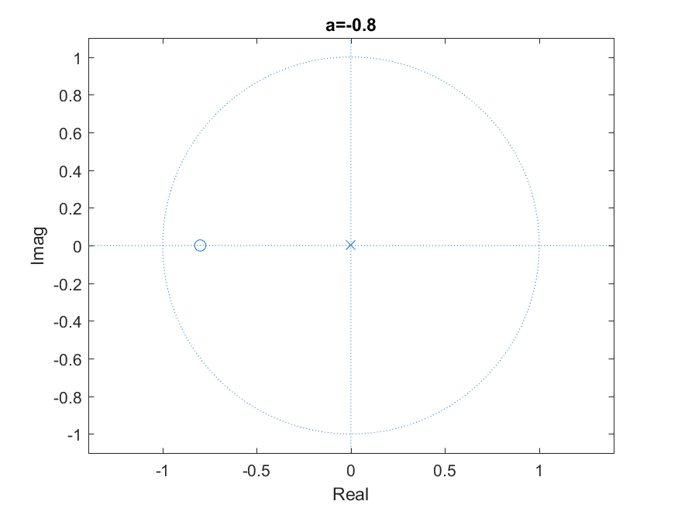

Figure 5: Low-Pass Filter

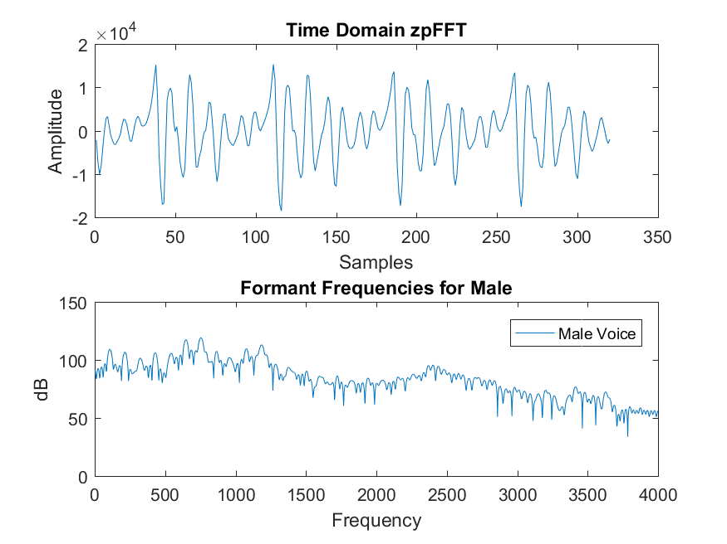

Figure 6: Formant Frequencies for a Male saying “/a/”. The first three formants can be observed to occur around 750 Hz, 1250 Hz, and 2400 Hz.

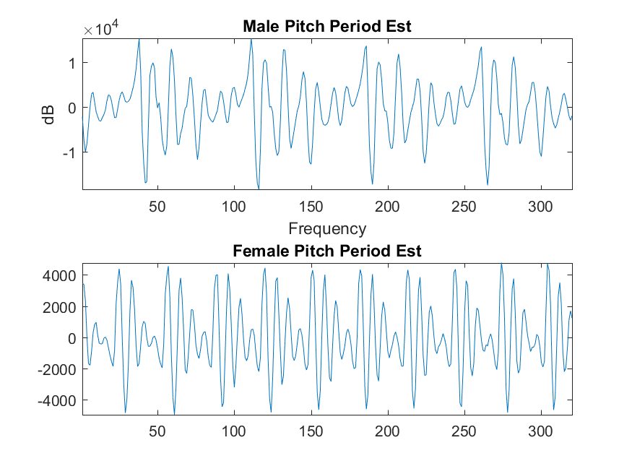

Figure 7: Pitch Period Estimates of a Female and Male saying “/a/”. The male voice seems to have a medium-low lobe at sample 150 that repeats at 223, which corresponds to a pitch period of about 73 samples. In seconds, this is: $T=\frac{Samples}{SampleRate}=\frac{73}{8000}=.009125 seconds$. This corresponds to a fundamental frequency of: $\frac{1}{T}=109.58 Hz.$ The Female voice seems to have a low lobe at 155 and 185, which is about 30 samples. In seconds, this is $T=\frac{30}{8000}=.00375 seconds$. This corresponds to a fundamental frequency of: $\frac{1}{T}=266 Hz$

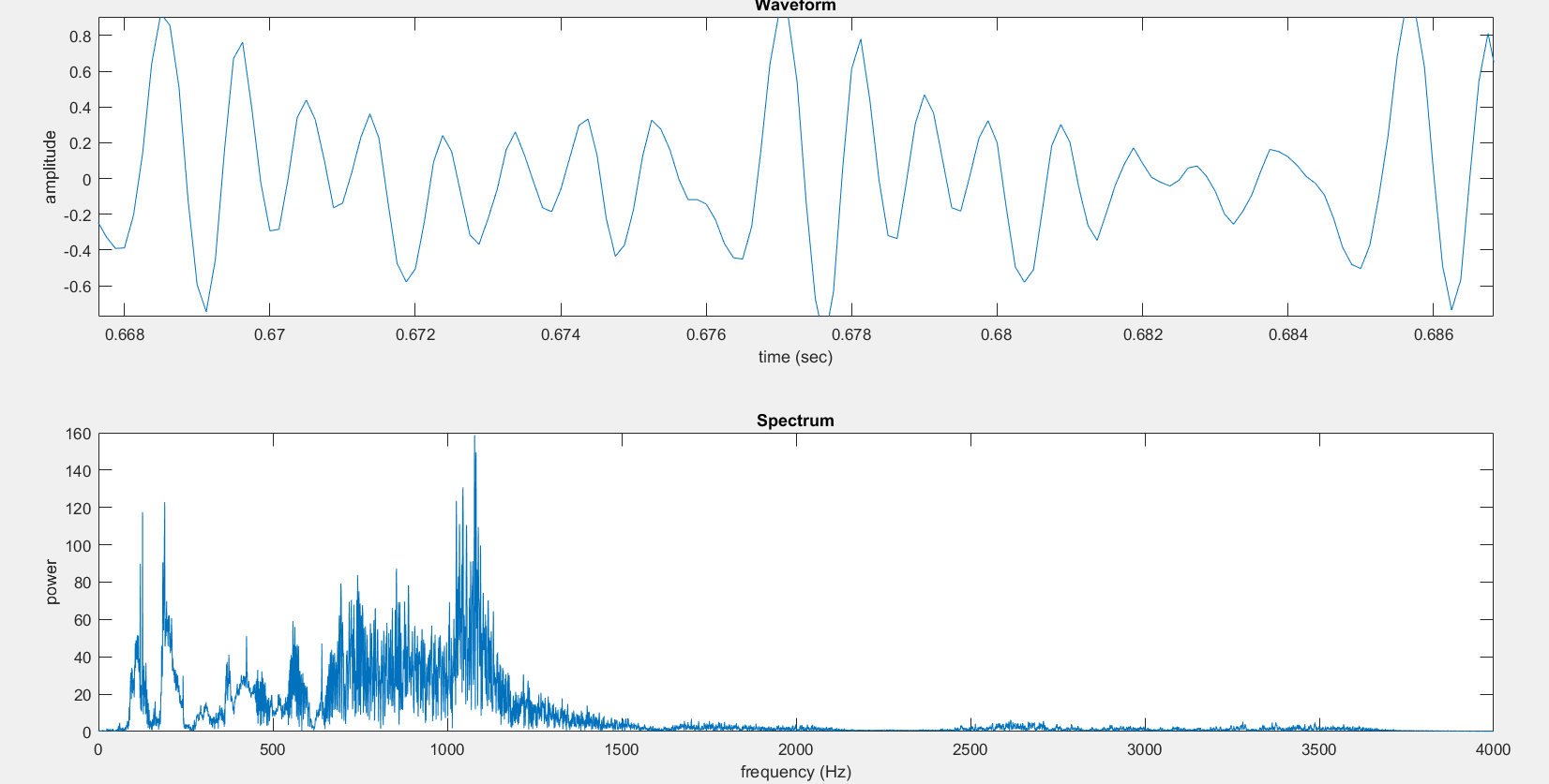

Figure 8: My own voice. There is a low-lobe at about t = 0.6692 that repeats at about t = (13/16)(0.678 – 0.676) + 0.676 = 0.67625. This corresponds to a period of 0.008425 seconds, and a fundamental frequency of $\frac{1}{T}=118.69 Hz$

Matlab code below:

